EXP. NO: 8
Mini Project-Dark Sky Tourism Analytics
AIM:
To clean, process, and visualize dark sky tourism data covering destinations, celestial events, sky quality, visitor ratings, travel costs, and tourism revenue using Python, and build static (Matplotlib and Seaborn) visualizations along with Power BI and Tableau dashboards to derive insights on astro-tourism trends.
DOMAIN:
Dark Sky Tourism Analytics
PROBLEM STATEMENT:
In the context of growing interest in astro-tourism and stargazing travel, travelers and destination planners lack a unified visual dashboard that compares dark sky quality, celestial events, seasonal demand, visitor satisfaction, travel costs, and tourism revenue across countries. There is a need for a data-driven visualization system to compare dark sky destinations and extract meaningful insights about the best places, seasons, and events for night sky tourism.
OUTPUT:
Python:
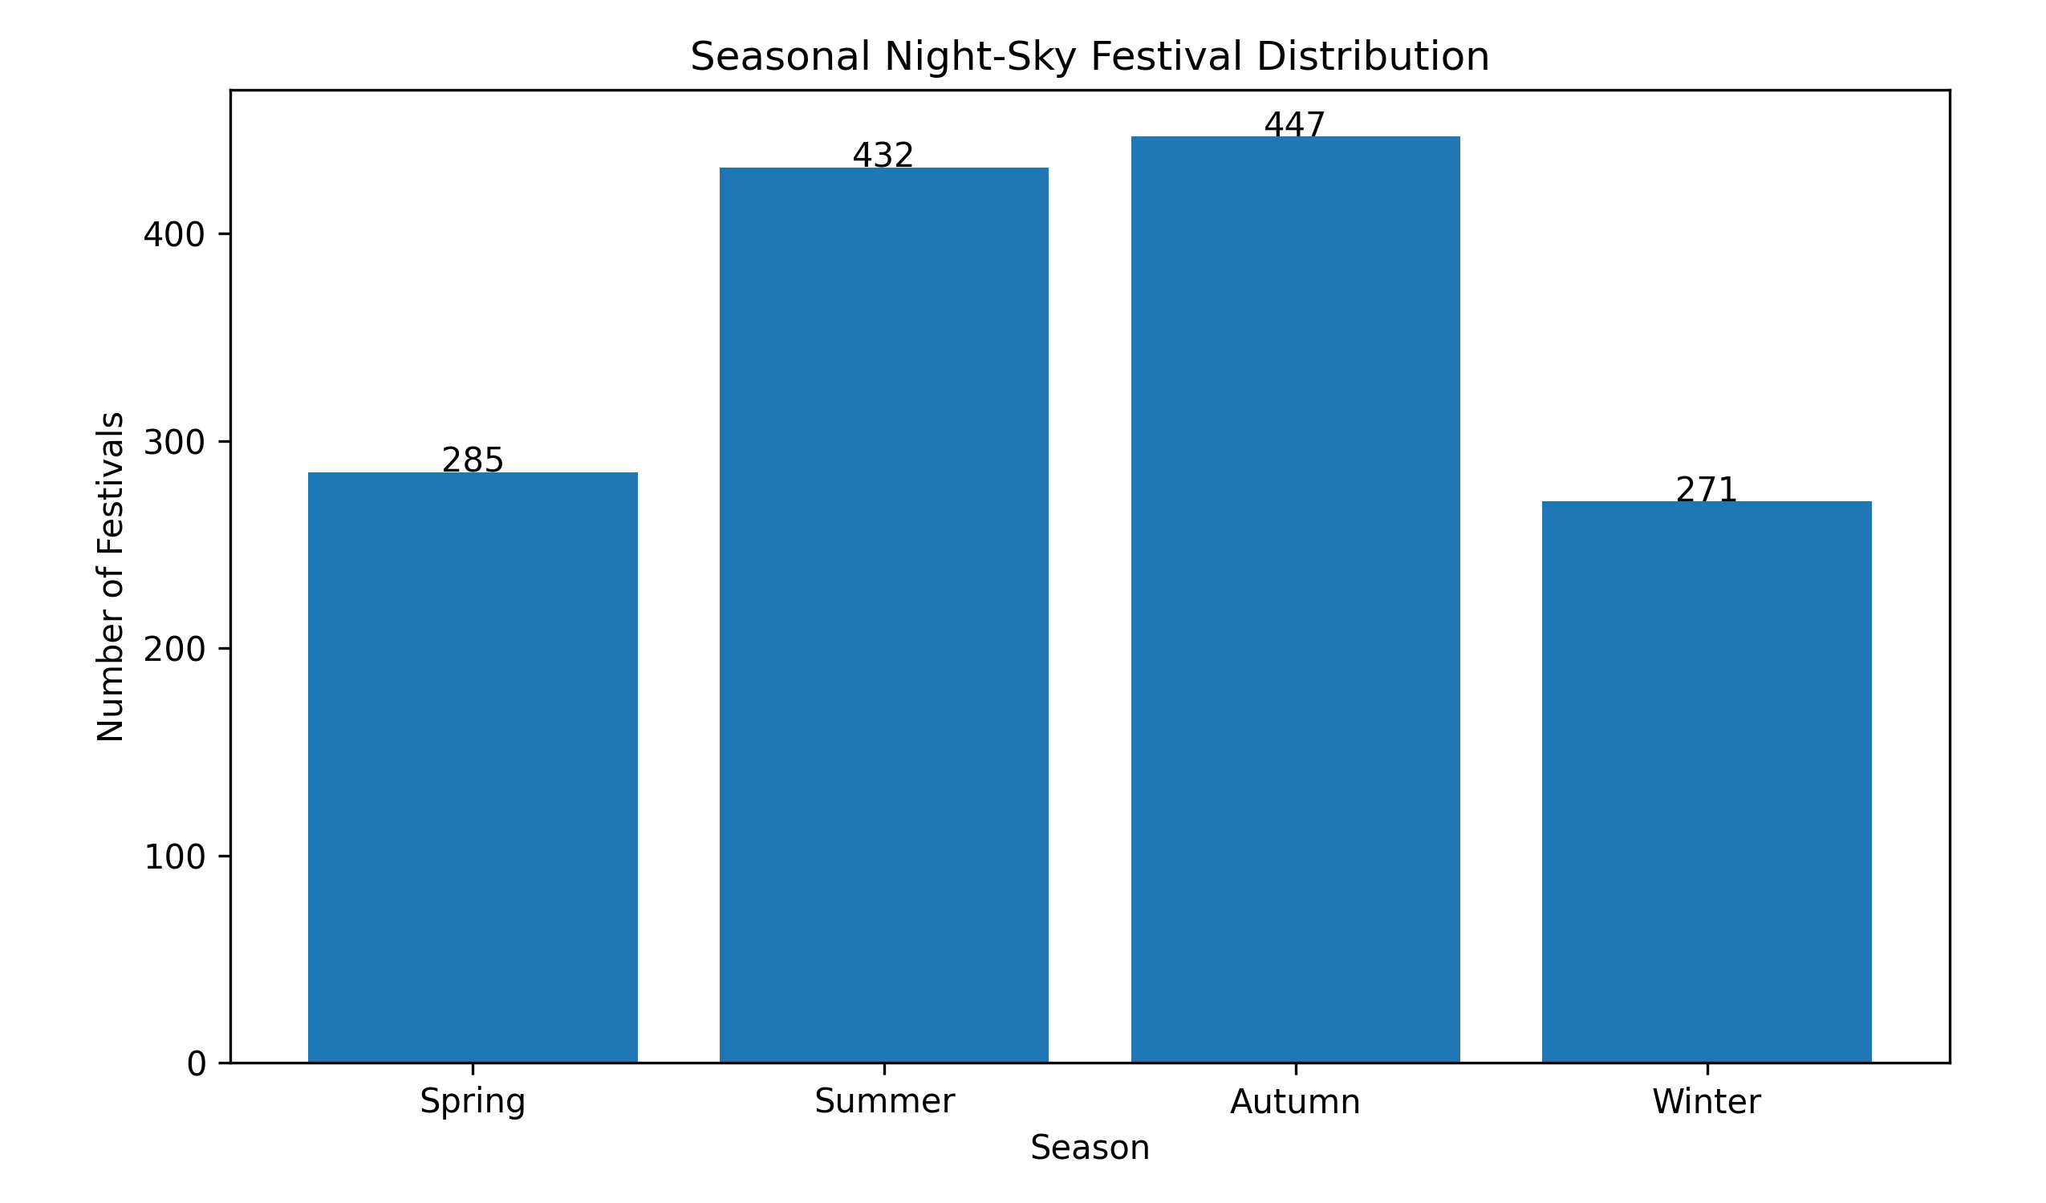
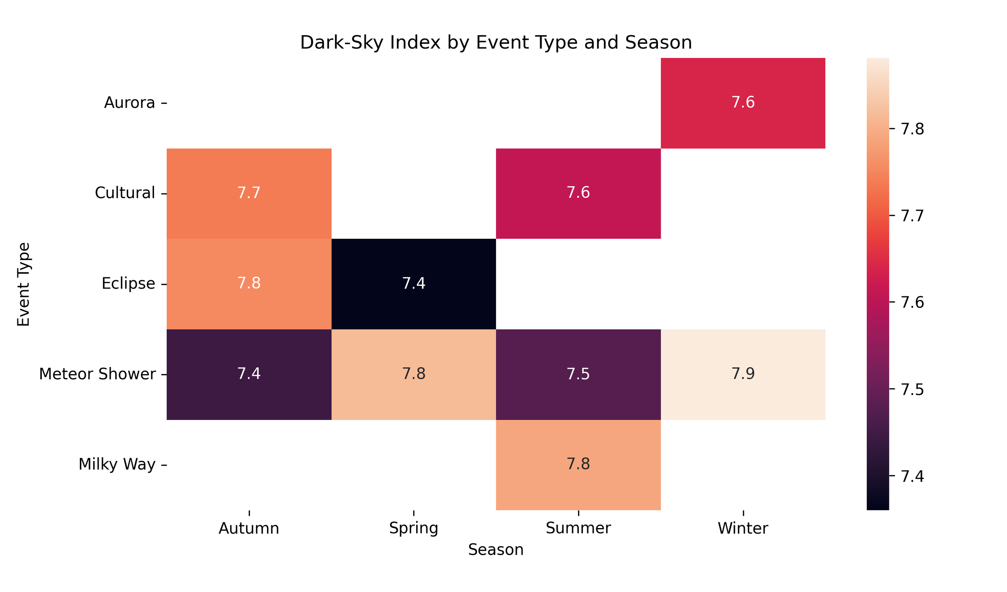
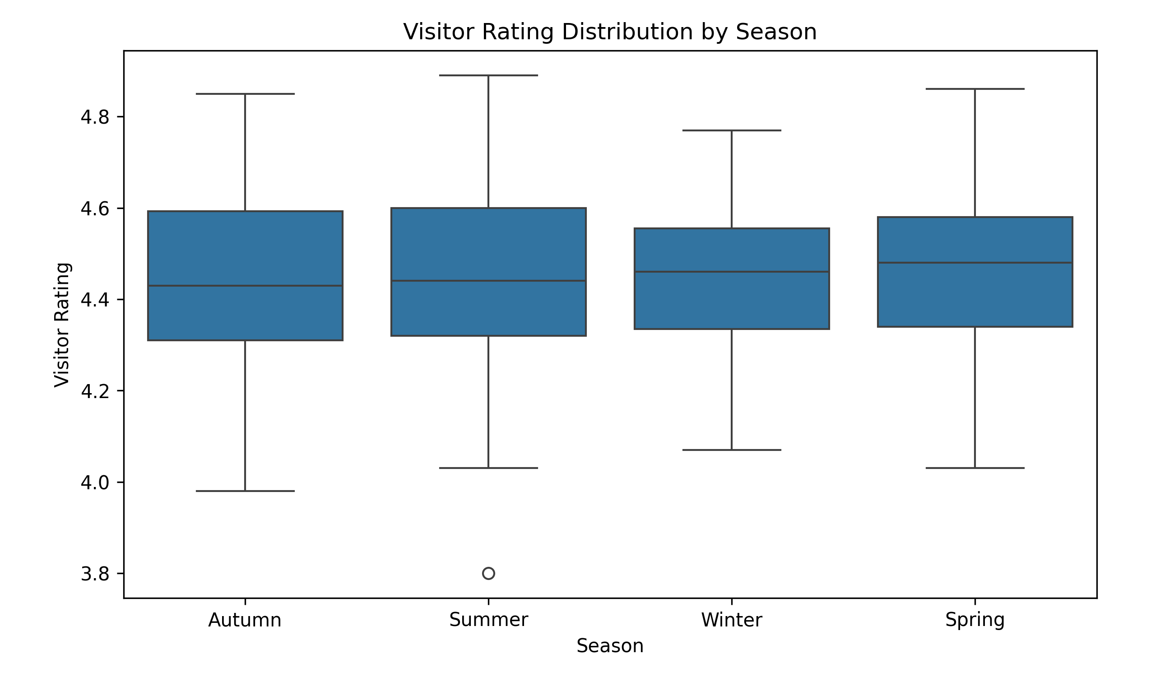
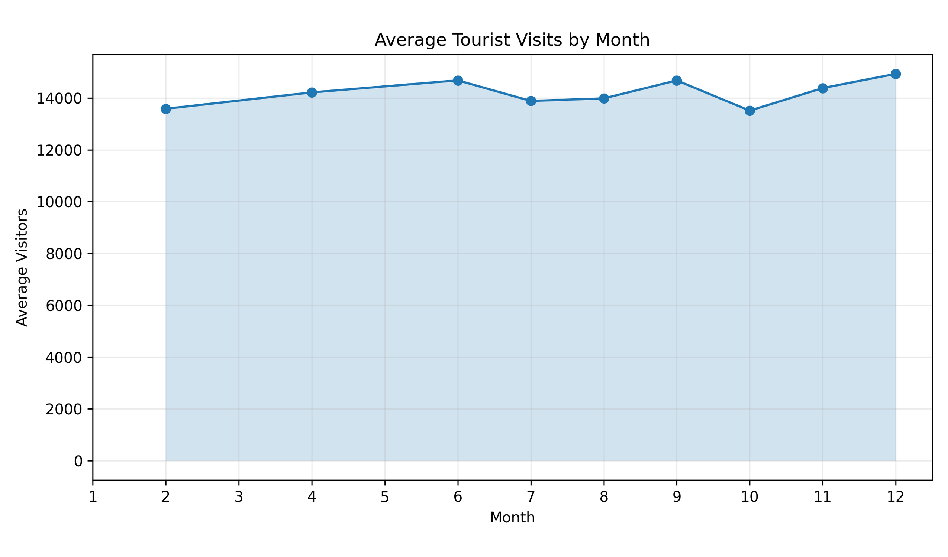
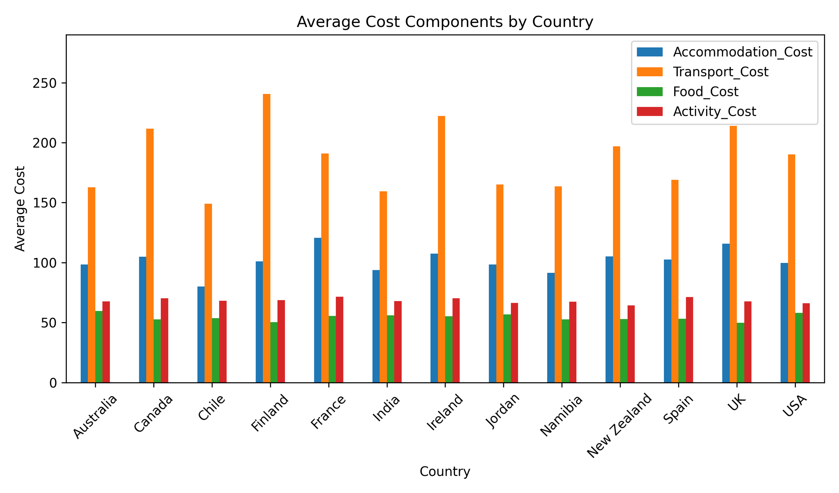
PowerBI:
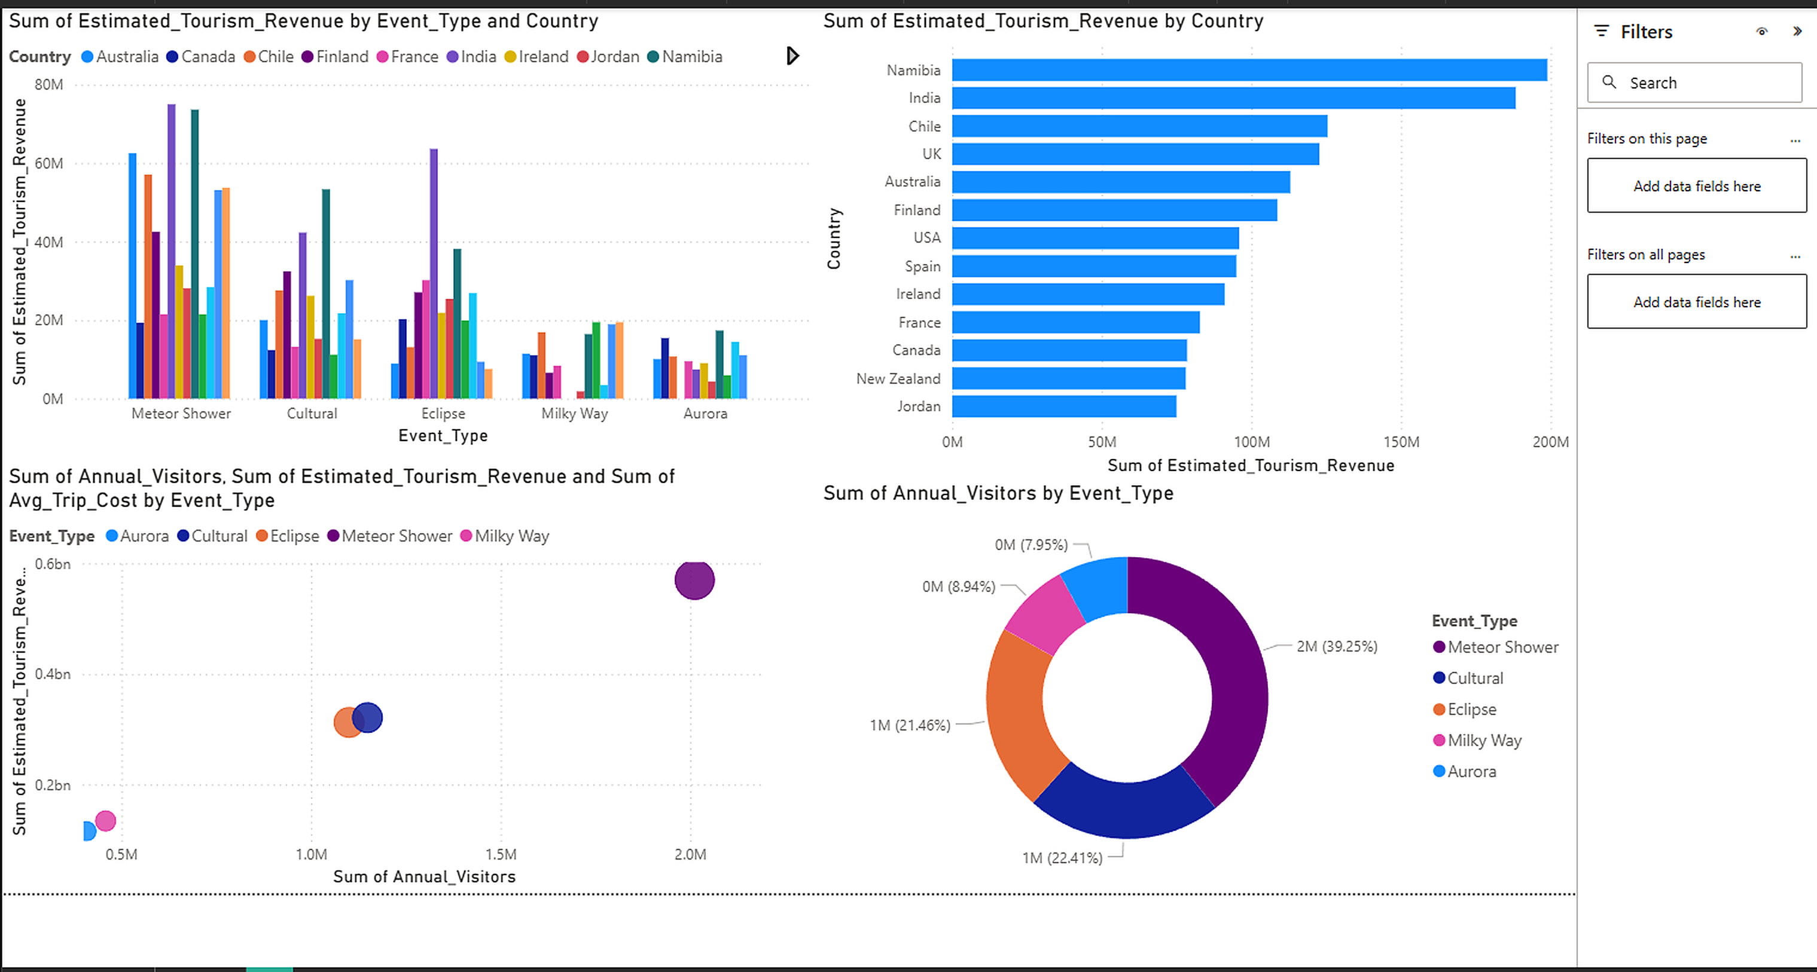
Tableau:
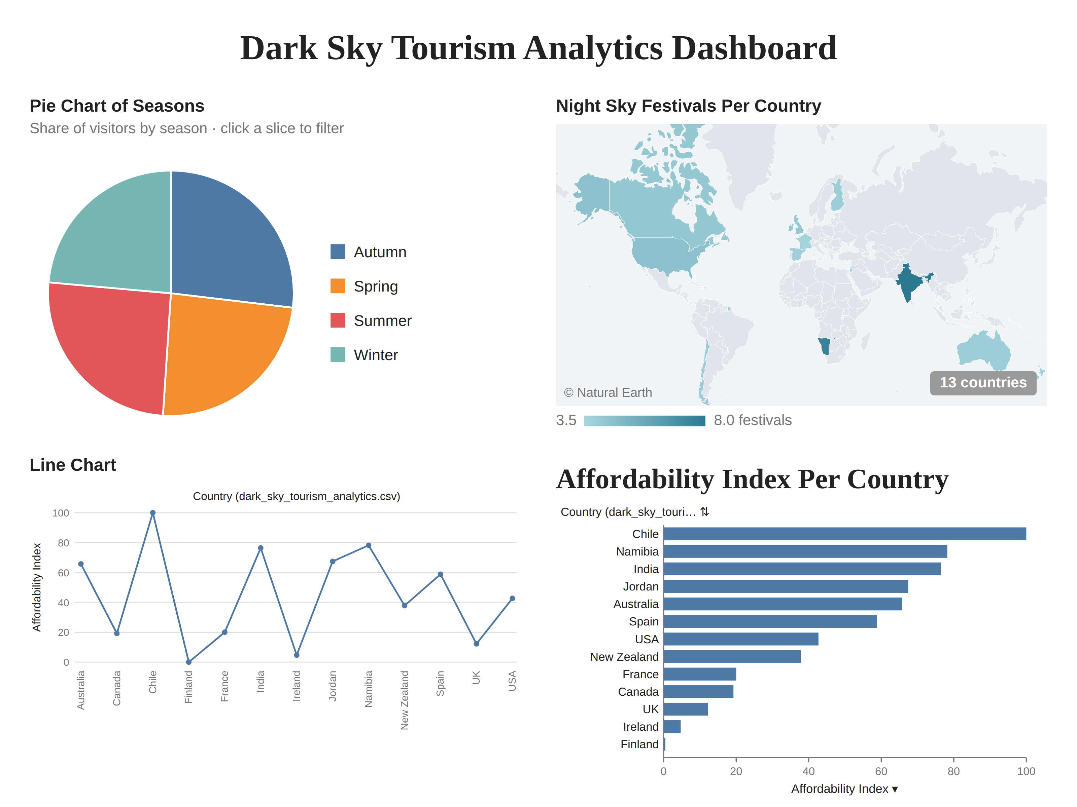
RESULT:
Thus, the given program was written and executed successfully.

